CREATIVE EDUCATIONAL SERVICES
END OF TERM I EXAMINATIONS
2024

WRITING

NAME: ____________________________________________ BABY CLASS





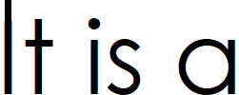

****Good luck****

